CAPTAIN C



Table of contents

* Description of website
* Version History and Could services
* Typography
* Colours
* Wireframe Section
* Screen Capture Section

Description of website

The web application “Game Tracker” gives details about the games like: Soccer, Tennis, Cricket, and Baseball and its scores, results and spectators.

The Web application includes a Main Game Tracking Page and allows users to register and Login to make any changes related to the games.

There are some other pages in the web application like: Default.aspx, CreateMatch, EditMatch, and etc.

The Main Game Tracking Page will allow a registered user who is logged in to enter the statistics and data related to 4 games or contests held between two teams during any calendar week.

During each calendar week, each Game will include a name, a short description, total points scored by both teams combined, the number of spectators and a designated winning team.

Version History and Cloud Services

Part -1

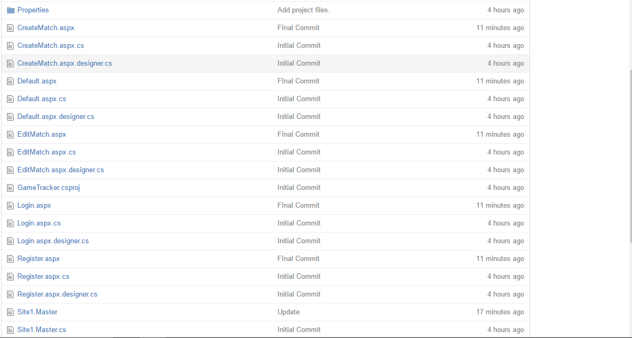

[http://gametrackerpart1.azurewebsites.net](http://gametrackerpart1.azurewebsites.net/)

<https://github.com/naga-georgian/GameTracker_Part1>

Part -2

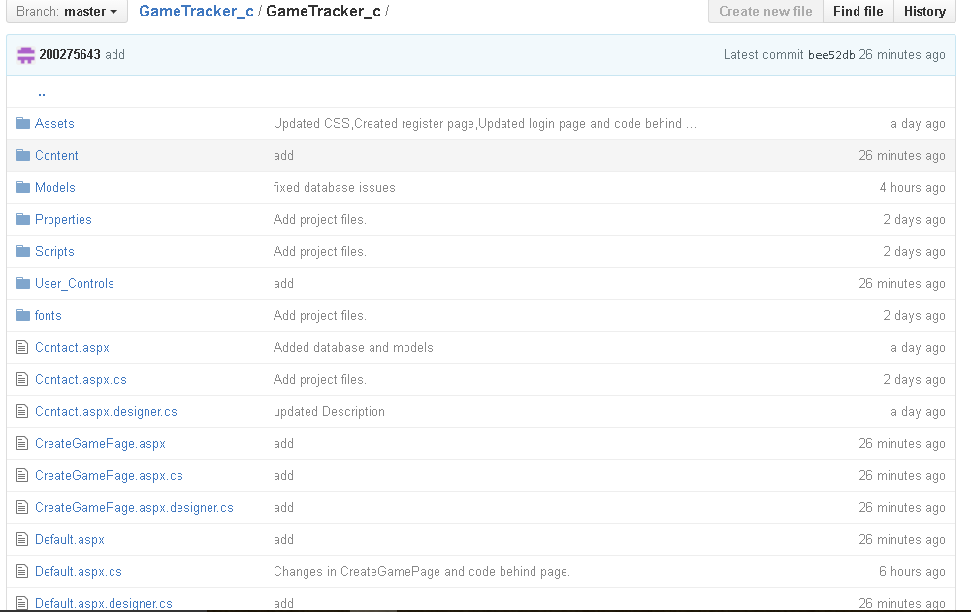

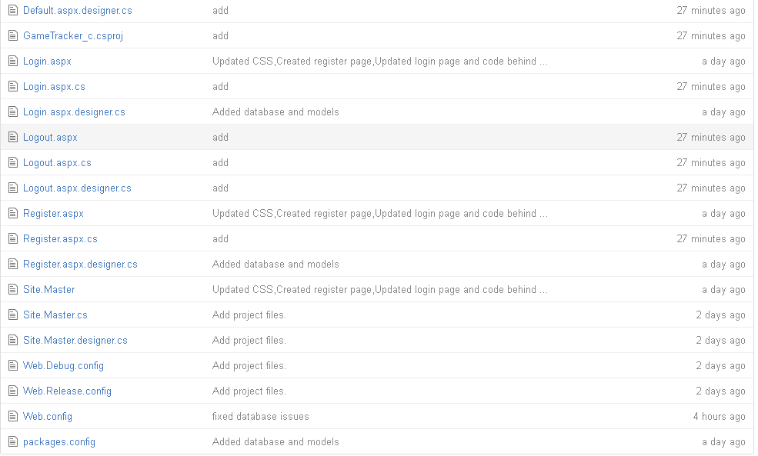

<http://gametracker1.azurewebsites.net>

<https://github.com/200275643/GameTracker_c>

We have changed the structure of the web application and implemented a new structure. Below wireframes and screenshots give a good idea on how it looks like.

Typography

Arial Narrow, Arial, sans-serif, Helvetica.

Colors

Navigation bar Consists of Dark Grey color (#323232) with the White color page Headings on it.

The title of the web application ‘Captain C’ and the text Game Stats is Red (#ff0000) in colour.

For Login button, register link and register button in register page, we have used light blue (#2B679C)

In register page, for cancel button we have used orange colour (#EEA640).

The color is black (#000000) and dark grey (#323232) in the entire Application for ‘Main Game Tracking Page’, ‘Login Page’, ‘Home Page’ etc.…

Wireframes

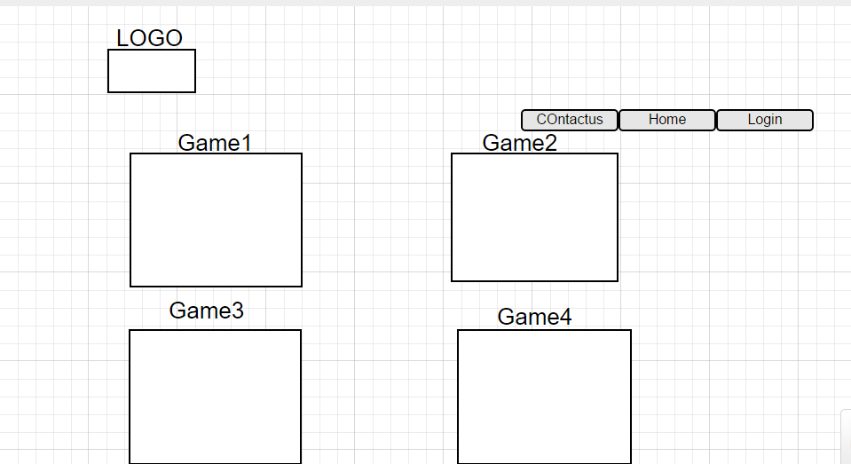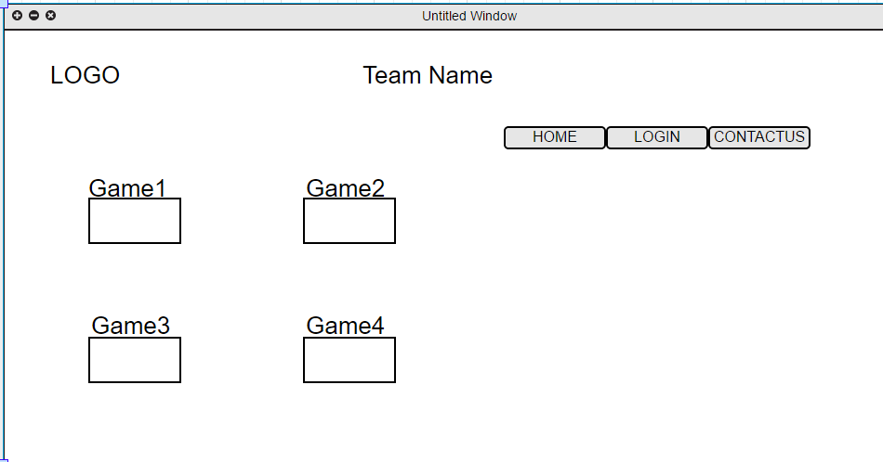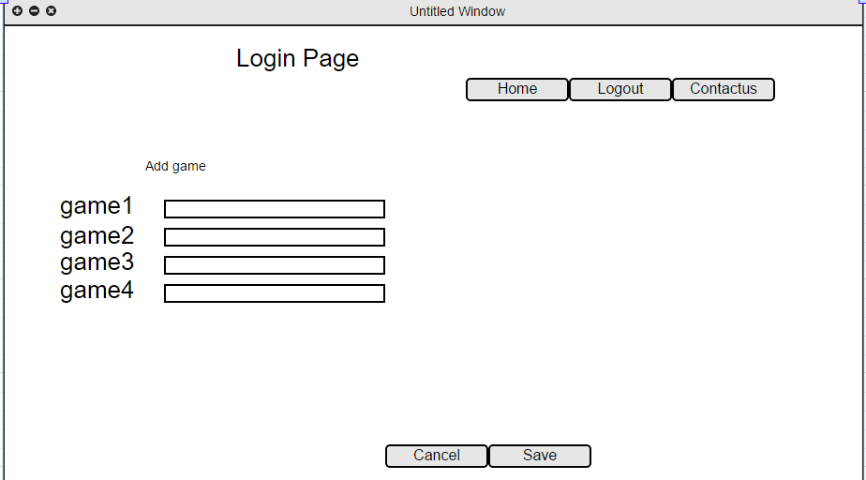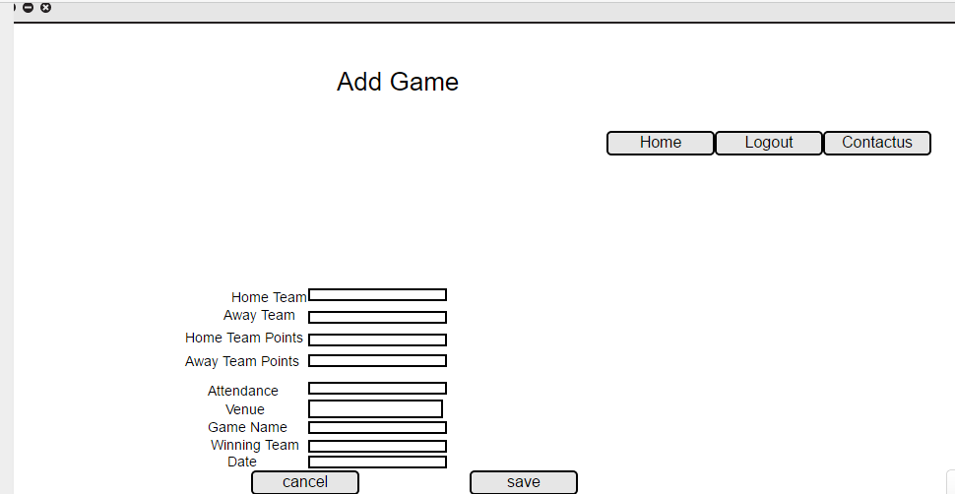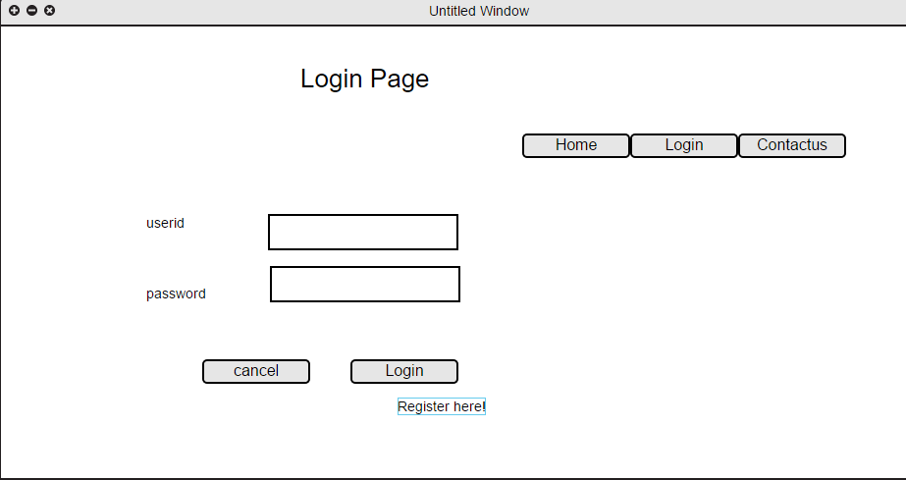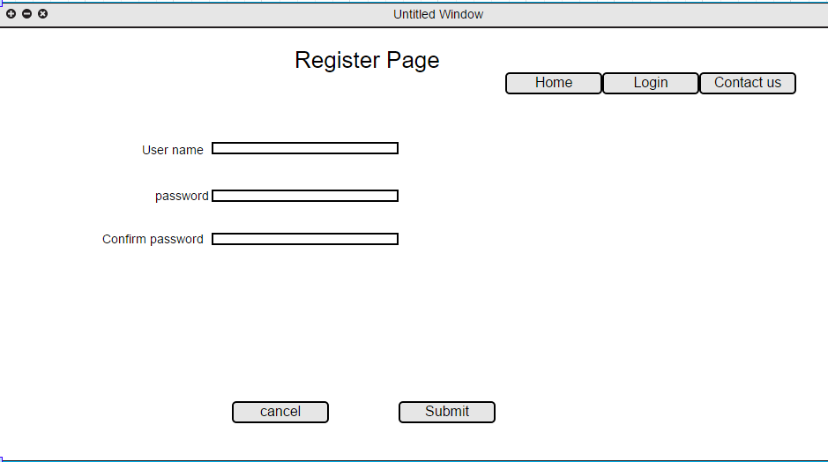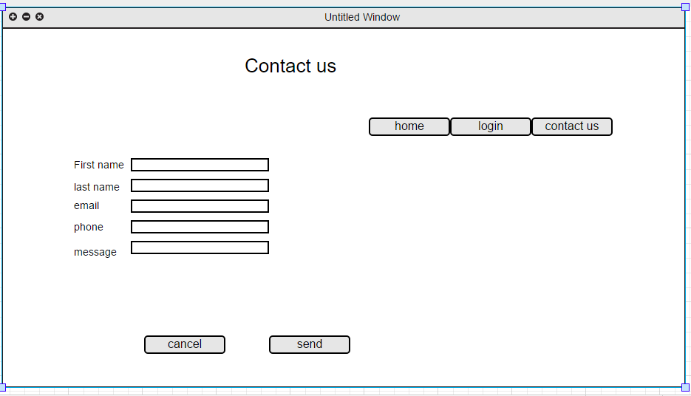

Screen Capture Section

